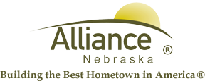

January 21, 2026

FOR IMMEDIATE RELEASE

Valentine Box Event with Keep Alliance Beautiful and Alliance Public Library
Alliance, NE – Join Keep Alliance Beautiful and Alliance Public Library for our annual Valentine Box event for all ages with, families welcome! On Monday, February 2 from 4:15 to 6:00 pm in the APL Community Room, all supplies are provided for your Valentine Box masterpieces.
For more information, please contact Cynthia Horn, Children’s and Youth Services Librarian at (308) 762-1387.

