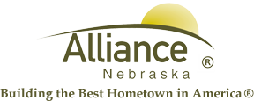

January 19, 2026

FOR IMMEDIATE RELEASE

RSVP 2026 MLK Food Drive
Alliance, NE – RSVP staff would like to remind the community about the MLK Community Needs Drive happening right now! Each January, RSVP staff and volunteers participate in a MLK Community Food Drive. The idea is to perform an “act of service” in honor of the memory of Martin Luther King Jr. The act of service we chose is to conduct a Needs Drive that will restock the shelves of our local Food Pantries, provide warm hands and emergency needs that are depleted from holiday demand. The items collected will be donated to local Food Pantries. The hope is to replenish our Food Pantries and needs so they will have supplies available for the immediate hunger and emergencies families may have.
We invite and challenge you to donate nonperishable food items, hats and gloves, and/or to conduct your own mini Needs Drive for the week of January 19th – 23rd. RSVP staff will pick up your donated food items and add them to the overall collection. Please let us know if you will join the challenge.
Call RSVP at (308) 762-1293 for more information about how you can make a difference!
For more information, contact Angie Flesner at (308) 762-1293 or aflesner@cityofalliance.net.

