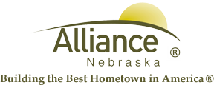

December 31, 2025

FOR IMMEDIATE RELEASE

January Digital Detox Fridays at Alliance Public Library
Alliance, NE – Digital Detox Fridays at Alliance Public Library will feature a Snowman Craft with Keep Alliance Beautiful on January 9, Winter Watercolor on January 16, Winter Crafts on January 23 and STEAM Activities on January 30. For preschool and over, all events are in the APL Community Room from 10-11 am, with families welcome! All supplies are provided for your creative projects and STEAM kits remain at the library for future use.
For more information, please contact Cynthia Horn, Children’s and Youth Services Librarian at 762-1387.

