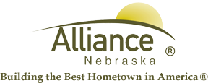

December 23, 2025

FOR IMMEDIATE RELEASE

Landfill Temporary Rollout Dumpster Pickup Schedule
Alliance, NE – The City of Alliance Landfill will be picking up rollout dumpsters on Friday, December 26th, due to the Holidays falling on Wednesday, December 24th, and Thursday, December 25th.
Due to this temporary schedule change, the Landfill is allowing citizens to put any trash into their blue rollout dumpster if their black rollout dumpster becomes full. The lid to the blue rollout dumpster must remain open to be picked up on Friday, December 26th.
For any questions, please contact the Landfill at (308) 762-2705.

