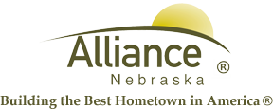

November 24, 2025

FOR IMMEDIATE RELEASE

December Story Time & LEGO Club at Alliance Public Library
Alliance, NE – Story Time themes at Alliance Public Library for ages 3-6 include Authors & Illustrators on December 2 and 4, Time to Rhyme on December 9 and 11 then Hooray for Holidays on December 16 and 18. Story Time meets in the Children’s Room with several stories, birthdays, music, puppets and craft on Tuesdays at 10 am and Thursdays at 1 pm.
LEGO Club for grades K-2 meets on Tuesdays, December 2 and 16 from 4-5 pm. LEGO Club for grades 3-5 meets on Tuesday, December 9 from 4-5 pm. Both groups meet in the APL Community Room and all LEGO supplies remain at the library for future use.
For more information, please contact Cynthia Horn, Children’s and Youth Services Librarian at 762-1387.

