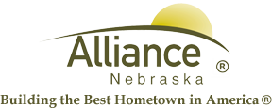

November 20, 2025

FOR IMMEDIATE RELEASE

Closures of City Facilities

Alliance, NE – The City of Alliance Facilities will be closed Thursday, November 27th and Friday, November 28th in observance of Thanksgiving. This closure includes the Utility Office, Public Works and the Municipal Building.

Public Transit will be closed Thursday, November 27th and Friday, November 28th.

The Alliance Municipal Landfill will be closed Thursday, November 27th thru Sunday, November 30th.

Alliance Public Library will also be closed Thursday, November 27th thru Sunday November 30th for the holiday weekend.

The Knight Museum & Sandhills Center will be closed on Thursday, November 27th and Friday, November 28th. They will reopen on Saturday, November 29th for the first day of the Annual Christmas Festival.

The Sallows Military Museum will be closed Thursday, November 27th and Friday, November 28th. They will open from 11am to 4pm on Saturday, November 29th and will be closed on Sunday, November 30th.

Please contact the City Administration Offices at (308) 762-5400 for any questions or for more information.

