For Immediate Release
November 13, 2025
Media Contact:
Troy Shoemaker, Fire Chief
308-762-2151

Alliance Fire Apparatus Engineer/AEMT Recognized for 20 Years of service as an EMT

Allen Lorensen, a Fire Apparatus Engineer/AEMT for the Alliance Fire Department was recently recognized by the Board of Directors of the National Registry of Emergency Medical Technicians (NREMT) for achieving 20 consecutive years of National EMS certification. This distinction is an honor held by few EMS professionals.

To maintain his status as a Nationally Registered EMT, Lorensen completed, on a biennial basis, the most comprehensive recertification program for EMS professionals in America.

By maintaining his National EMS Certification and completing regular continuing education courses, Lorensen has demonstrated his commitment to providing exceptional prehospital emergency medical care.

Lorensen was Nationally Registered as an EMT in 2004 and has been serving the Alliance community since 2012. Prior to this position, Lorensen worked for the Page Fire Department, Page Arizona as a Firefighter/EMT and before that was a Volunteer with the Alliance Fire Department.

The National Registry of Emergency Medical Technicians serves as the National EMS Certification organization by providing a valid, uniform process to assess the knowledge and skills required for competent practice by EMS professionals throughout their careers and by maintaining a registry of certification status.

### END ###

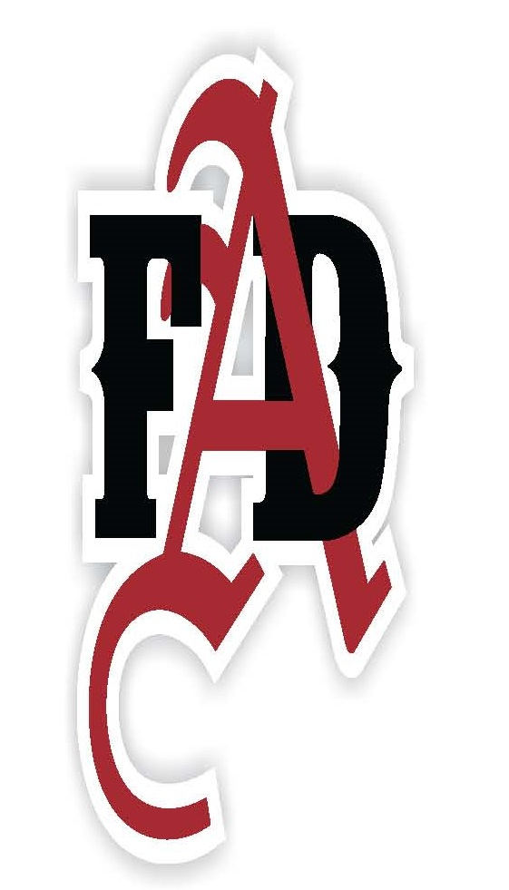 Alliance Fire Department ~ 315 Cheyenne Avenue ~ Alliance, NE 69301~ (308) 762-2151

