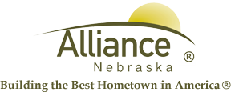

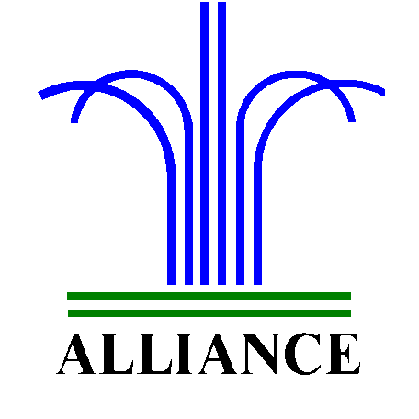 City of Alliance ~ P. O. Box D ~ Alliance, NE 69301~ (308) 762-5400

August 20, 2025

FOR IMMEDIATE RELEASE

Prairie Dog Educational Meeting at Knight Museum & Sandhills Center

Alliance, NE – Box Butte County will be hosting a Prairie Dog Educational Meeting on Tuesday, August 26, 2025 at 2:00 pm at The Knight Museum & Sandhills Center.

For any questions, please call (308) 760-3701.

