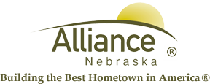

July 18, 2025

FOR IMMEDIATE RELEASE

Temporary Suspension of School Transportation Services at Alliance Public Transit
Alliance, NE – Due to a current shortage of available staff, we regret to inform you that, effective immediately, we are unable to provide transportation services for school children to or from school.
We understand the inconvenience this may cause and sincerely apologize for the disruption. Please know that we are actively working to address staffing challenges and will continue to monitor the situation closely.
We will provide updates as soon as circumstances change and transportation services can be resumed.
Thank you for your understanding and cooperation during this time.
For any questions, please contact Megan Smith, Public Transit Director, at (308) 762-7433.

