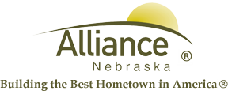

June 9, 2025

FOR IMMEDIATE RELEASE

Flag Retirement at Sallows Military Museum

Alliance, NE – The American Legion will be presenting a flag retirement ceremony at the Sallows Military Museum on Flag Day, Saturday, June 14th beginning at 10:00am.

If you have old or tattered flags, please bring them to the Sallows Military Museum on or before June 13th.

For more information, please contact the Sallows Military Museum by calling (308) 762-2385.

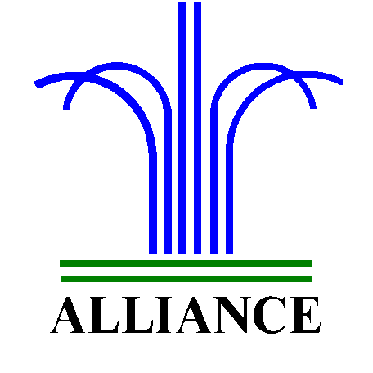 City of Alliance ~ P. O. Box D ~ Alliance, NE 69301~ (308) 762-5400

