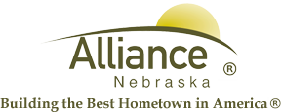

June 3, 2025

FOR IMMEDIATE RELEASE

Water Department Updating Water Meter Radios

Alliance, NE – A reminder that the City of Alliance Water Department is still in the process of updating water meter radios in residential areas that are regularly accessed by meter readers. Ordinance Number 2120 Section 28-199 can be referenced for information on authorized access.

The Water Department will only access properties during the business hours of 7:00 AM and 5:00 PM Monday through Friday. Employees will be wearing some form of high-visibility clothing and will be accompanied by a City vehicle.

For more information, please contact Public Works at 762-1907.

