

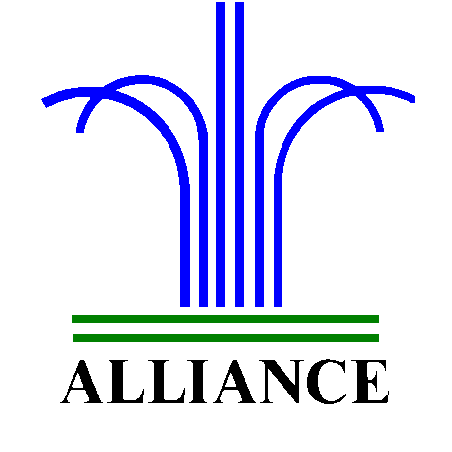City of Alliance ~ P. O. Box D ~ Alliance, NE 69301~ (308) 762-5400

May 14, 2025

FOR IMMEDIATE RELEASE

Big Blue Bay Season Passes Available

Alliance, NE – Pool Passes for the 2025 swim season will be available at the Knight Museum & Sandhills Center starting May 19, 2025. Passes will be available for purchase on weekdays from 8:00am to 7:00pm, Saturdays from 10:00am to 6:00pm, and Sundays from 1:00pm to 5:00pm.
Important: All customers MUST bring a 1” square photo of themselves to be included on each individual pass. If you have a group photo, individuals can be cut out for separate passes. Alternatively, a copy of a photo ID may be used. Steph’s Studio in Alliance can print photos from a phone or other device while you wait.
Pass Pricing:
Household pass: $150.00
17 and under: $65.00
18 and older: $80.00
Lap Swim Only: $50.00

Swim lesson registration will continue through Friday, May 23, also at the Knight Museum & Sandhills Center. This deadline ensures staff have time to finalize class rosters.

For any inquiries or further information, please don't hesitate to contact the Knight Museum at 762-2384.

