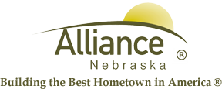

April 22, 2025

FOR IMMEDIATE RELEASE

REAL ID Reminder

Alliance, NE – Officials with the Transportation Security Administration (TSA) and Alliance Municipal Airport would like to remind the public that starting Wednesday, May 7, 2025, every air traveler 18 years of age and older (including those flying domestically) who do not present a REAL ID-compliant license or acceptable alternative form of identification, such as a passport can expect to face delays, additional screening, and possibility of not being permitted into the security checkpoint. This requirement is outlined in the REAL ID Act, which mandates federal agencies to accept only state-issued driver’s licenses and ID cards that meet specific security standards.
To determine if a Nebraska driver’s license or identification card is REAL ID-compliant, look for the gold star in the upper righthand corner. The presence of this star indicates the credential is REAL ID-compliant.

