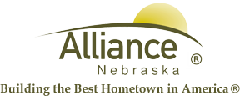

February 27, 2025

FOR IMMEDIATE RELEASE

Story Time and LEGO Club at Alliance Public Library

Alliance, NE – Story Time A to Z at Alliance Public Library for ages 3-6 will feature Terrific T for March 4 and 6, Spectacular St. Patrick’s for March 11 and 13, Undercover with U for March 18 and 20 then What’s New? for March 25 and 27 plus Show and Tell Time. Story Time includes several stories, birthdays, music, puppets and crafts in the APL Children’s Room. LEGO Club for grades K-3 will meet on Tuesdays, March 4 and 18 from 4-5 pm in the APL Community Room for preregistered participants.
For more information, please contact Cynthia Horn, Children’s and Youth Services Librarian at 762-1387.

