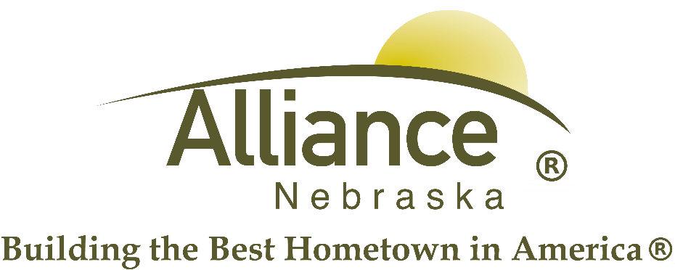

February 24, 2025
FOR IMMEDIATE RELEASE
Transit Facebook Post Press Release
Alliance, NE – A Facebook message that posted this morning around 8:00, local time, is currently circulating with three council members tagged. This post reads: “Councilman Tacy Liptack, Travis Turman, Jay Weisgerber, are you aware your city manager is cutting hrs, when they need to hire more, and telling city workers, that he is going to do away with City Transit Services??? Telling them there is no funding.. this article clearly states there is a funding, as long as they turn the paperwork in on time. what is it going to take to get rid of this guy.”
At this time, the City of Alliance wishes to clarify and rebut the misinformation presented in the above-referenced Facebook post.
- Hours are not being cut. Transit will continue to serve the public from 6:30 am – 4:30 pm, Monday through Friday, except City-observed Holidays. What is occurring is that transit drivers will be changing from a four-day, ten-hour shift (4-10’s) to a five-day, eight-hour shift (5-8’s) effective March 10, 2025. Full-time employees will continue to work forty hours per week. Part-time employees will continue to work as needed.
This change is being effected to accomplish the following:
  - Have more buses available each day, utilizing all five buses/vans on a daily basis. If a van or bus needs repair work and is unable to drive, this schedule allows the driver to make arrangements to deliver the out of commission vehicle to be repaired.
  - Have better coverage throughout the day during peak times – specifically from 7:30 – 8:00 am, from 11:30 am – 12:00 noon, and from 3:30 – 4:00 pm. This decision is based on data collected since January 2024 via our dispatching software which show that these periods are the highest ridership periods during the day.
  - Reduce the impact of a single employee being unable to fill a shift. The current 4-10 schedule relies on three full time drivers and one dispatcher. A single employee missing reduces our capacity to serve by 1/3rd. While we do have two part-time employees who help tremendously to fill in gaps whenever possible, it is not always possible to do so on short notice, as we experienced just last Friday when a bus was temporarily taken out of commission right before the end of school day rush. The City must also be conscious of how many hours these part-time employees work as it may shift them into a different employment category according to FLSA rules. Having five drivers through the majority of the day means that if a single employee must miss work that day, service is only reduced by 20%, and we would still have one more bus/van on the road than we currently do with the existing 4-10 schedule.
  - Reduce unnecessary overtime created by the current 4-10 schedule to cover those employees who currently take a day one of the five workdays off, covering vacation and sickness leave, trainings, etc. This will result in providing a lower cost of service to the Citizens of Alliance.
  - Allow for improved maintenance of the vans and buses, keeping them on the road and minimizing costs of repairs.
- The need to hire more drivers.
  - This is a misstatement which is likely perpetuated by the current 4-10 schedule which inherently introduces services shortfalls as described above. As long as we are able to maintain our current staffing of five full-time and two part-time drivers, we end up having more drivers than we have vehicles. We do have one more vehicle on order, however its intent is to replace an aged-out vehicle, not to increase the number of vehicles we have on the road.
- Doing away with transit services and no funding.
  - Untrue.
  - The following is what is true: The Nebraska Department of Transportation has informed us as recently as our quarterly Zoom meeting on February 18, 2025 that we should not expect to be able to add additional employees to our staff nor additional vehicles to our fleet (not including replacement vehicles) in the coming three years due to their anticipation that the public transit program will not receive any more funding than they currently receive and the rise in requests from transit departments across the state. The City is currently in the process of renewing its grant application with the State to continue to provide Transit Services, and while there is no guarantee that we will receive these funds, we are hopeful given our performance of that grant since 2016. That application is due in March 2025.
In summary, we anticipate that the above changes will lower costs and improve our service levels to the Citizens of Alliance. As always, citizens are welcome to contact the City Manager, Seth Sorensen at 308-762-5400 or via email at ssorensen@cityofalliance.net to discuss concerns regarding Public Transit or any other concerns that they may have regarding city services.

