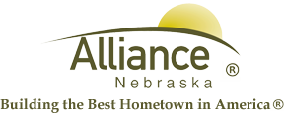

February 14, 2025

FOR IMMEDIATE RELEASE

President’s Day Closures of City Facilities

Alliance, NE – The City of Alliance Facilities will be closed Monday, February 19, 2024, in observance of President’s Day. This closure includes the Utility Office, Public Works, Knight Museum & Sandhills Center, Sallows Military Museum, Alliance Public Library, The Senior Center, Public Transit, Landfill, and the Municipal Building.

Please contact the City Administration Offices at (308) 762-5400 for any questions or for more information.

