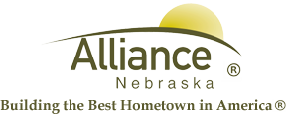

January 23, 2025

FOR IMMEDIATE RELEASE

Story Time, Searchers and LEGO Club at Alliance Public Library

Alliance, NE – Upcoming Story Time themes for ages 3-6 at Alliance Public Library include Quest for Q on February 4 and 6, Be My Valentine on February 11 and 13, Racing with R on February 18 and 20 then Splendid S on February 25 and 27. Story Time meets in the Children’s Room on Tuesdays at 10 am and Thursdays at 1 pm with several stories, birthdays, puppets, music and craft.

Preschool through second grade are invited to Search for Sherbet Unicorn during library hours with one search per day and one prize per child from January 27 through February 14.

LEGO Club for grades K-3 meets on Tuesdays, February 4 and 18 from 4-5 pm in the APL Community Room for preregistered participants.

For more information, please contact Cynthia Horn, Children’s and Youth Services Librarian at 762-1387.

