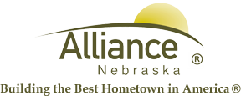

January 15, 2025

FOR IMMEDIATE RELEASE

MLK Food Drive 2025 Press Release

Alliance, NE – RSVP staff would like to remind the community about the MLK Community Needs Drive happening right now! Each January, RSVP staff and volunteers participate in a MLK Community Food Drive. The idea is to perform an “act of service” in honor of the memory of Martin Luther King Jr. The act of service we choose is to conduct a needs drive that will restock the shelves of our local food pantries, provide warm hands and emergency needs that are depleted from holiday demand. The items collected will be donated to local Food Pantries and WCHR. The hope is to replenish our food pantries and needs so they will have supplies available for the immediate hunger and emergencies families may have.

We invite you to individually donate nonperishable food items, hats and gloves, unisex deodorant, laundry pods, household cleaners, bodywash & dish soap OR we challenge you to conduct your own mini Needs Drive at your work or in your personal life during the week of Jan. 16-21st.

RSVP staff will pick up any donations collected to add to the overall collection. Please let us know if you will join the challenge. Call RSVP 762-1293 for more information about how you can make a difference!

For more information, contact Angie Flesner at 762-1293 or aflesner@cityofalliance.net
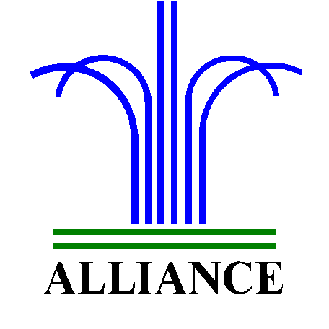 City of Alliance ~ P. O. Box D ~ Alliance, NE 69301~ (308) 762-5400



