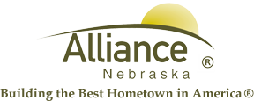

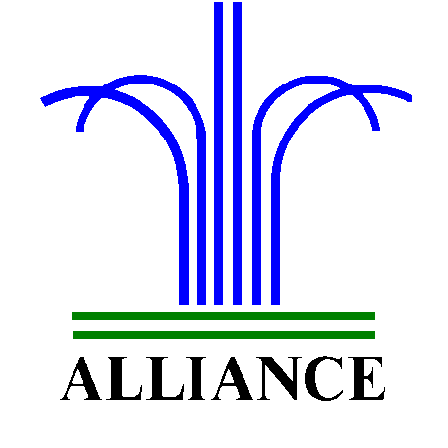City of Alliance ~ P. O. Box D ~ Alliance, NE 69301~ (308) 762-5400

January 7, 2024

FOR IMMEDIATE RELEASE

Delayed Opening of Landfill for Computer Replacement

Alliance, NE – The Alliance Landfill will open later than usual on Wednesday, January 8th due to scheduled computer system replacement.
During this time, access to the landfill will be inaccessible to the public. In the event that the replacement process is completed ahead of schedule, the landfill will open at its regular time. We encourage you to call ahead to confirm operating hours before your visit.
We appreciate your understanding during this essential maintenance. For more information, please contact the Landfill at 308-762-2705.

