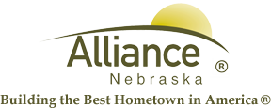

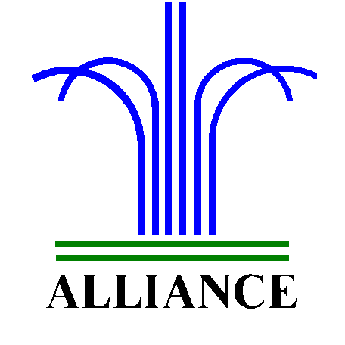City of Alliance ~ P. O. Box D ~ Alliance, NE 69301~ (308) 762-5400

December 26, 2024

FOR IMMEDIATE RELEASE

Story Time Adventures and LEGO Club at Alliance Public Library

Alliance, NE – Story Time A to Z will feature Nifty N on January 7 and 9, Outstanding O on January 14 and 16, Winter Wonderland on January 21 and 23 then P is for Pajama Party on January 28 and 30. Story Time for ages 3-6 meets in the Children’s Room on Tuesdays at 10 am and Thursdays at 1 pm with several stories, birthdays, music, puppets and craft.

LEGO Club for grades K-3 will meet on Tuesdays, January 7 and 21 from 4-5 in the Community Room.

For more information, please contact Cynthia Horn, Children’s and Youth Librarian at 762-1387.

