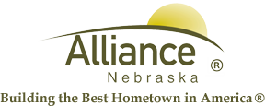

December 13, 2024

FOR IMMEDIATE RELEASE

Public Transit BOGO

Alliance, NE – Public Transit is offering BOGO rides with a $5 or more purchase until December 31st.
For more information, please contact Public Transit at (308) 762-7433 or (308) 761-7433.

