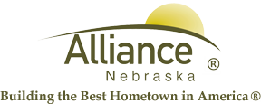

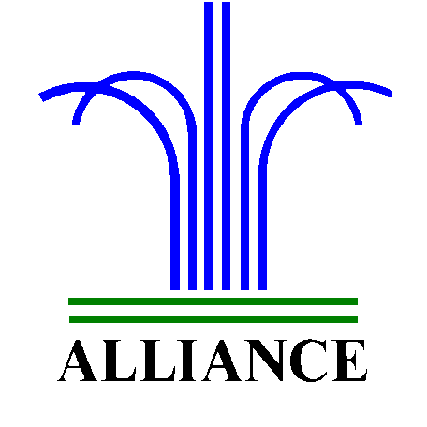 City of Alliance ~ P. O. Box D ~ Alliance, NE 69301~ (308) 762-5400

December 12, 2024

FOR IMMEDIATE RELEASE

Alliance Landfill Updated Hours

Alliance, NE – The Alliance Landfill has begun their new hours of operation for December 1 through March 31, being Monday through Friday: 8:30 a.m. to 4:15 p.m. and closed on Saturdays and Sundays.

For more information, please contact the Alliance Landfill at (308) 762-2705.

