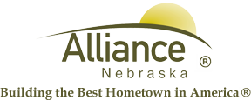

December 11, 2024

FOR IMMEDIATE RELEASE

Gift Wrapping Senior Center Fundraiser

Alliance, NE – Support the Valentine’s Day Dinner for Senior Citizens!
The Alliance Nutrition Site and RSVP is hosting a fundraiser to support a special Valentine's Day Dinner for our Senior Citizens, and we need your help!

- Monday, December 16, 2024 – Friday, December 20, 2024: 10:00 AM – Noon
- Saturday, December 21, 2024: 10:00 AM – 2:00 PM

Bring your donations to the Alliance Nutrition Site during these hours to get your holiday gifts wrapped and show your support for this heartwarming event. Your generous donations will help make this Valentine's Day Dinner a memorable experience for our seniors.
Let’s spread some love this holiday season!

For more information, please contact Angie Flesner at (308) 762-1293.

