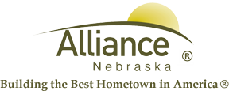

December 10, 2024

FOR IMMEDIATE RELEASE

Scam Phone Calls Regarding Utility Accounts

Alliance, NE – The City of Alliance has been notified of utility customers receiving phones regarding their utility accounts and threats of their power being turned off. Please be aware that this is a scam and these calls are not coming from City of Alliance Utility Office Staff. Please do not give any Personal Identifiable Information to these callers. If you are unsure about the validity of a phone call or if the caller is asking for Personal Identifiable Information, please hang up and call the direct number to the Alliance Utility Department (308) 762-5075.
If you have fallen victim to this scam, please contact the Non-Emergency Police Department line at (308) 762-4955 to file a report.
If you have any questions, please call the Utility Department at (308) 762-5075.

