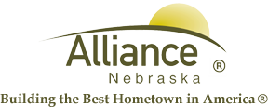

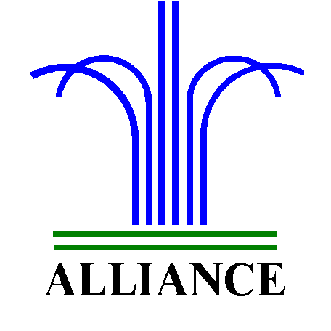City of Alliance ~ P. O. Box D ~ Alliance, NE 69301~ (308) 762-5400

December 3, 2024

FOR IMMEDIATE RELEASE

Abominable Snow Monster Stuffy & Movie at Alliance Public Library

Alliance, NE – Alliance Public Library invites kindergarten and up for an Abominable Snow Monster Stuffy Workshop and Movie with cost of $25. Payment is due at registration and the event will be held in the APL Community Room on Friday, December 13 from 3 to 4:30 pm. Spots are limited so please sign up early with registration due by Thursday, December 12. Rudolph movie refreshments will be provided by the Alliance Public Library Foundation.

Please contact Cynthia Horn, Children’s and Youth Services Librarian at 762-1387 for more information.

