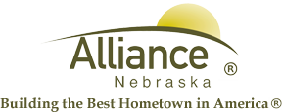

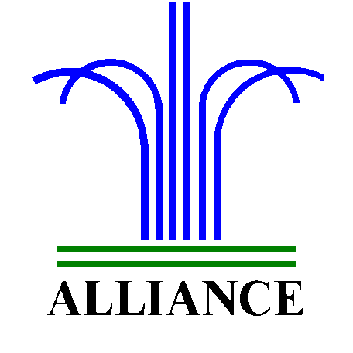 City of Alliance ~ P. O. Box D ~ Alliance, NE 69301~ (308) 762-5400

December 3, 2024

FOR IMMEDIATE RELEASE

Collection of Roll -Out Waste Containers

Alliance, NE – With the holiday season upon us, The Alliance Municipal Landfill will be closed the following days, closing at noon Tuesday, December 24 through Wednesday, December 25, 2024 and Wednesday, January 1, 2025. Refuse collection of curbside roll-out waste containers will be on Thursday, December 26, 2024, as well as Thursday, January 2, 2025.

For more information, please contact the Alliance Landfill at (308) 762-2705.

