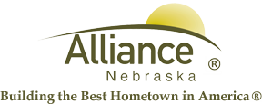

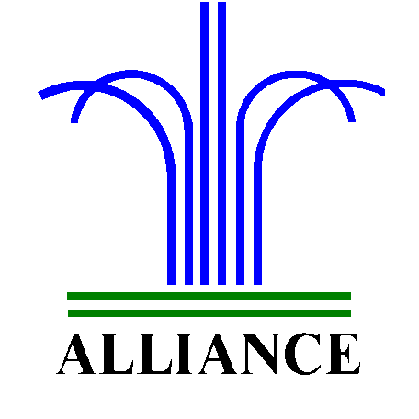City of Alliance ~ P. O. Box D ~ Alliance, NE 69301~ (308) 762-5400

November 27, 2024

FOR IMMEDIATE RELEASE

Holiday Crafts with Keep Alliance Beautiful at Alliance Public Library

Alliance, NE – Join Keep Alliance Beautiful and Alliance Public Library for Holiday Crafts with preschool and over on Thursday, December 5 from 4-5 pm in the APL Community Room. Bring your family to craft together with all supplies provided.

For more information, please contact Cynthia Horn, Children’s and Youth Services Librarian at 762-1387.

