

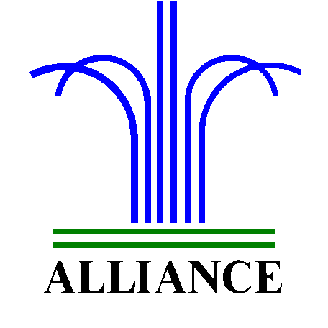City of Alliance ~ P. O. Box D ~ Alliance, NE 69301~ (308) 762-5400

November 26, 2024

FOR IMMEDIATE RELEASE

Tree of Love

Alliance, NE – Box Butte County RSVP invites and challenges you to include a local nursing home resident in your Christmas giving this year. RSVP will set up a “Tree of Love” at Carter’s on Tuesday, November 26th. This tree will be decorated with ornaments listing gift suggestions for the residents of Highland Park. In Hemingford there is a tree set up at Valor General Store that is decorated with ornaments listing gift suggestions for the residents of Hemingford Care Center.
To share in the true spirit of Christmas, stop into Carter’s or Valor’s, select an ornament and purchase a gift for a nursing home resident. Gifts should be left at Carter’s or the Hemingford Care Center no later than Wednesday, December 20th
For more information, please contact Angie Flesner at (308) 762-1293.

