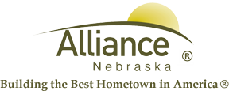

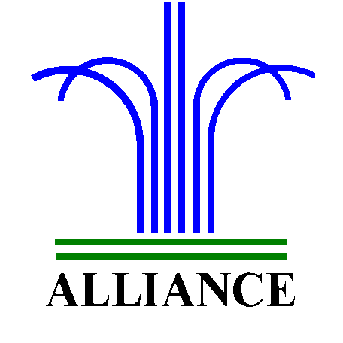City of Alliance ~ P. O. Box D ~ Alliance, NE 69301~ (308) 762-5400

November 26, 2024

FOR IMMEDIATE RELEASE

Story Time Adventures and LEGO Club at Alliance Public Library

Alliance, NE – Story Time A to Z for ages 3-6 at Alliance Public Library will feature Lively L on December 3 and 5, Majestic M on December 10 and 12 and Festive Holidays on December 17 and 19. Story Time is offered on Tuesdays at 10 am and Thursdays at 1 pm with several stories, birthdays, music, puppets and craft. Preschool through second grade can Search for Pete the Cat during library hours from December 2 through 24 with one prize per day and one prize per child during the month.

LEGO Club for grades K-3 will meet on Tuesdays, December 3 and 17 from 4-5 pm in the APL Community Room.

For more information, please contact Cynthia Horn, Children’s and Youth Services Librarian at 762-1387.

