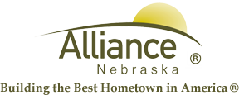

November 6, 2024

FOR IMMEDIATE RELEASE

Veterans Day Open House at Sallows Military Museum

Alliance, NE – The Sallows Military Museum is hosting their annual Veteran’s Day Open House on Monday, November 11th from 1:00pm-3:30pm at 1101 Niobrara Ave. Cider and cookies will be served.
For more information, please contact the Sallows Military Museum at (308) 762-2385.

