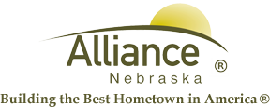

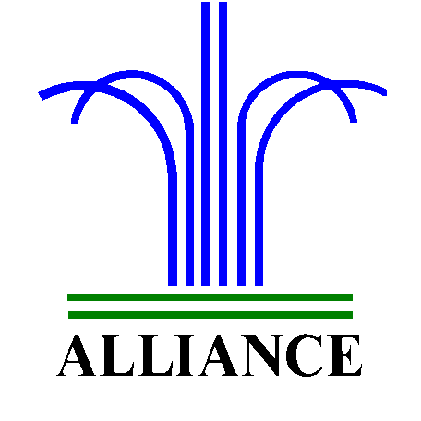City of Alliance ~ P. O. Box D ~ Alliance, NE 69301~ (308) 762-5400

October 28, 2024

FOR IMMEDIATE RELEASE

Story Time Adventures and LEGO Club at Alliance Public Library

Alliance, NE – Upcoming Story Time A to Z themes for ages 3-6 include Inspiring I on November 5 and 7, Joyful J on November 12 and 14 then Kind K on November 19 and 21. Story Time meets on Tuesdays at 10 am and Thursdays at 1 pm with no Story Time during Thanksgiving week.

Search for Butterball Turkey for preschool through second grade during library hours from November 4-27 with one prize per day and one prize per child during the month.

LEGO Club for grades K-3 will meet on Tuesdays, November 5 and 19 from 4-5 pm in the Community Room.

For more information, please contact Cynthia Horn, Children’s and Youth Services Librarian at 762-1387.

