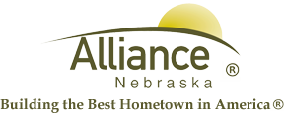

October 25, 2024

FOR IMMEDIATE RELEASE

Voice of Native American Women at Alliance Public Library

Alliance, NE – The Alliance Public Library will host the Humanities Nebraska presentation “Voice of Native American Women” by Independent Scholar Nancy Gillis on Thursday, November 7th at 6pm in the APL Community Room.

This presentation is a compilation of excerpts from primary documents in which Native American women’s comments, pleas and advice have been recorded, from the earliest records of negotiations with the colonists to contemporary women, including professionals, artists, and activists. In a series of readings, interspersed with background material, it explores the way native women have spoken out in political, social, and spiritual settings in humor, pathos, anger, and celebration, passing their legacy to the next generation.

Nancy Gillis is the former Executive Director of the John Neihardt State Historic Site, March 1997 - July 2019. Of Cherokee and Choctaw heritage, Gillis moved to Winnebago, Nebraska in 1987 to work with the Winnebago people for the Reformed Church in America and has served as their delegate to its Native American Council. She stays active in various civic organizations, currently or previously serving on the board of the Dr. Susan LaFlesche Picotte Hospital Board, State of Nebraska Historical Preservation Office, Nebraska Folklife Network, Atlas of Winnebago, and the Walthill Village Planning Commission.

Speakers are available to any non-profit organization in Nebraska. Each program lasts 30 minutes to an hour, plus a question-and-answer period. The most frequent users of the HN Speakers Bureau are primary and secondary schools, colleges and universities, libraries, museums and historical societies, agencies for the elderly, rural organizations, churches, arts organizations, and ethnic organizations. Humanities Nebraska sponsors the largest Speakers Bureau program in the U.S. according to the National Endowment for the Humanities.

For information detailing the available speakers and guidelines for booking them, please access our website at www.humanitiesnebraska.org (Speakers section) or contact Humanities Nebraska at 215 Centennial Mall South, Suite 330, Lincoln, NE 68508, phone (402) 474-2131, fax (402) 474-4852 or e-mail info@humanitiesnebraska.org.
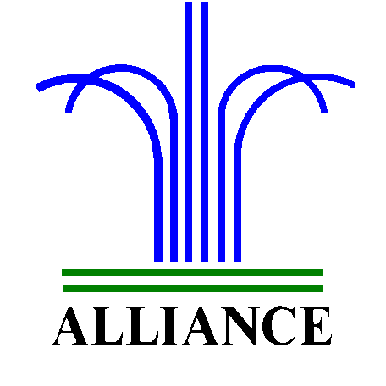City of Alliance ~ P. O. Box D ~ Alliance, NE 69301~ (308) 762-5400

For more information about the presentation, contact Adult Services Librarian, Nalani Stewart, at nstewart@cityofalliance.net or call 308.762.1387.
City of Alliance ~ P. O. Box D ~ Alliance, NE 69301~ (308) 762-5400

