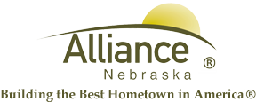

October 23, 2024

FOR IMMEDIATE RELEASE

2024 Yard Waste Collection End dates

Alliance, NE – The last days for yard waste collection will be Tuesday, November 26th for blue steel containers and Wednesday, November 27th for blue rollout bins.

For more information, contact Public Works Director Ross Grant at 762-1907.

