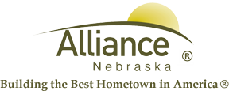

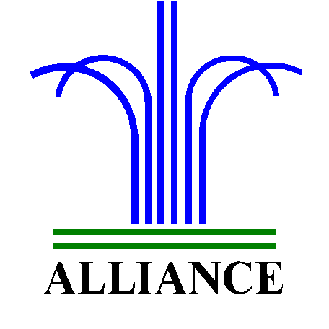 City of Alliance ~ P. O. Box D ~ Alliance, NE 69301~ (308) 762-5400

October 14, 2024

FOR IMMEDIATE RELEASE

Street Closure 2nd & Box Butte Avenue

Alliance, NE – Starting tomorrow morning at approximately 7:00 am, October 15, 2024, 2nd & Box Butte Avenue street will be closed for work on the BMO Bank. There will be a crane brought in for the job. The turning lane turning south on 3rd Street will also be closed. The street is anticipated to reopen on Wednesday, October 16th barring any unexpected circumstances.
For more information, please contact Brain Herndon of Snell Services at 308-629-8000.

