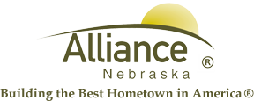

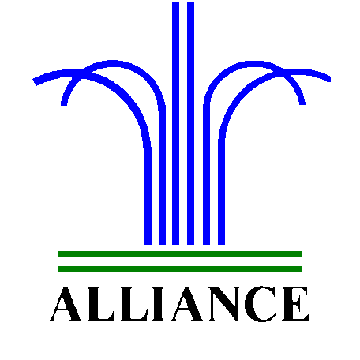City of Alliance ~ P. O. Box D ~ Alliance, NE 69301~ (308) 762-5400

October 14, 2024

FOR IMMEDIATE RELEASE

Doves Community Awareness Workshop at Alliance Public Library

Alliance, NE – The Alliance Public Library and the Doves Program will host a Community Awareness Workshop on Thursday, October 24th at 5pm in the APL Community Room. Speakers Madison Sweet and Jody Motz will discuss poverty and the impact on domestic violence, explore resources in our community, and discuss actionable strategies to support our community.
For more information, email nstewart@cityofalliance.net or call 308.762.1387.

