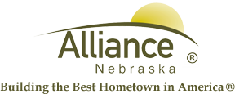

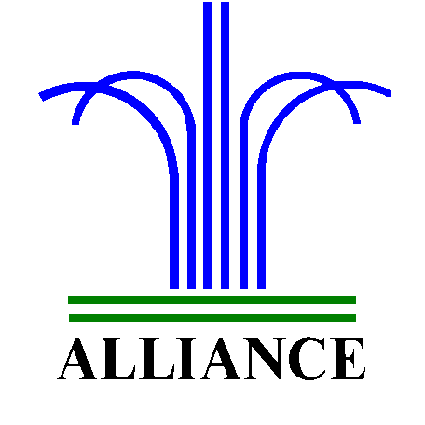 City of Alliance ~ P. O. Box D ~ Alliance, NE 69301~ (308) 762-5400

October 10, 2024

FOR IMMEDIATE RELEASE

Winterization of Central Park Fountain

Alliance, NE – Due to the colder weather upon us, City crews will begin winterizing the Central Park Fountain for the fall and winter months, starting on Monday October 14, 2024.

Please contact the Culture and Leisure Services Department at (308) 762-2384 for more information.

