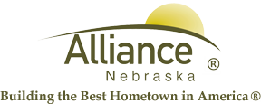

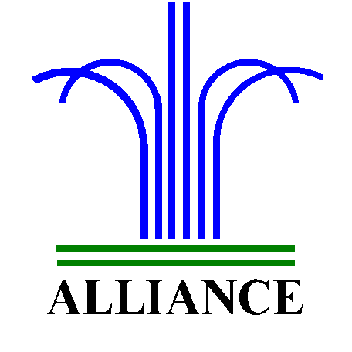City of Alliance ~ P. O. Box D ~ Alliance, NE 69301~ (308) 762-5400

September 30, 2024

FOR IMMEDIATE RELEASE

Story Time Adventures and LEGO Club at Alliance Public Library

Alliance, NE – Join us for Spooktacular events at Alliance Public Library during October!

Preschool through second grade are invited to Search for Gertie Ghost during library hours, October 1 through 31, with one prize per day and a limit of one prize per child during the month.

Story Time A to Z for ages 3-6 includes Exciting E for October 1 and 3 with guest readers from BBGH Building Blocks Playschool, F is for Fire Safety on October 8 and 10 with Alliance Fire Department, Glorious G on October 15 and 17, What’s New? plus Show and Tell on October 22 and 24 then H is for Happy Halloween plus Halloween Safety with Alliance Police Department and Costume Parade on October 29 and 31. Story Time is shared on Tuesdays at 10 am and Thursdays at 1 pm in the Children’s Room with several stories, music and craft.

LEGO Club for grades K-3 meets on Tuesdays, October 1 and 15 from 4-5 pm in the Community Room. Please preregister at the circulation desk for Story Time and LEGO Club.

For more information, please contact Cynthia Horn, Children’s and Youth Services Librarian at 762-1387.

