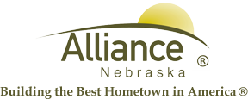

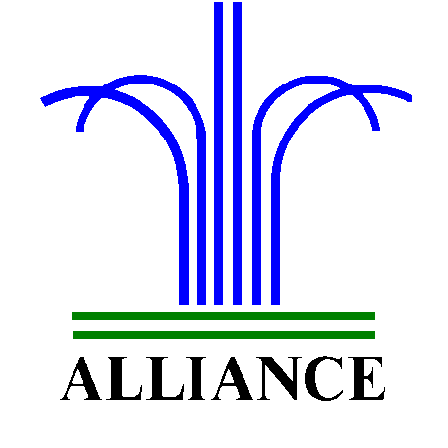City of Alliance ~ P. O. Box D ~ Alliance, NE 69301~ (308) 762-5400

September 18, 2024

FOR IMMEDIATE RELEASE

Dr. McConkey Author Event at Alliance Public Library

Alliance, NE – Dr. Josh McConkey (from Alliance, NE) is the award-winning and best-selling author of Be the Weight Behind the Spear, the 2024 Independent Press Award’s Distinguished Favorite in the Motivational Category. Dr. McConkey will be holding a reading and book signing event at the Alliance Public Library (1750 Sweetwater Ave.) on October 3rd, 2024 at 6 pm in the Community Room.

Dr. (Colonel) Josh McConkey is an esteemed Emergency Physician with over two decades of clinical experience. He served as a professor at Duke University and maintains Board Certification in Emergency Medicine. With 22 years of military service, Dr. McConkey now commands the 459th Aeromedical Staging Squadron in the US Air Force Reserves, demonstrating exceptional leadership and dedication. Beyond his medical and military achievements, Dr. McConkey has been recognized for his contributions to education and community. He was honored in 2022 with induction into the Alliance, Nebraska Public
Schools Hall of Fame and received the 2023 Distinguished Alumni Award from Chadron State College. A devoted father of three, his greatest passion lies in shaping future American leaders alongside his wife, Elsa, in Apex, North Carolina.

For more information on event please contact Cynthia Horn at: chorn@cityofalliance.net or call (308) 762-1387.

For Dr. McConkey directly: pr@joshmcconkey.com or call (919) 229-9042. Learn More online at: HTTPS://www.weightbehindthespear.com

