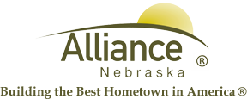

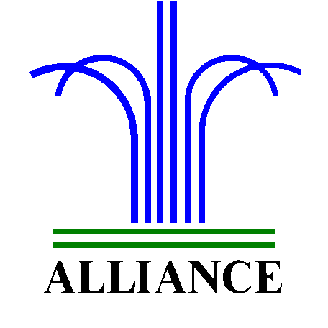City of Alliance ~ P. O. Box D ~ Alliance, NE 69301~ (308) 762-5400

September 6, 2024

FOR IMMEDIATE RELEASE

Stick Dog Adventure Book Club at Alliance Public Library

Alliance, NE – Join the Stick Dog adventure at Alliance Public Library with grades 3-5 for Adventure Book Club discussion on Friday, September 27 from 3:30-4:30 pm in the Community Room. Copies of “Stick Dog” by Tom Watson are available for checkout at the circulation desk with a $2.00 ILL fee. You are also invited to bring your own stories you have written and illustrated works to share.
For more information, please contact Cynthia Horn, Children’s and Youth Services Librarian at 762-1387.

