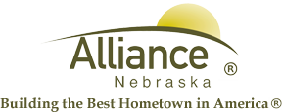

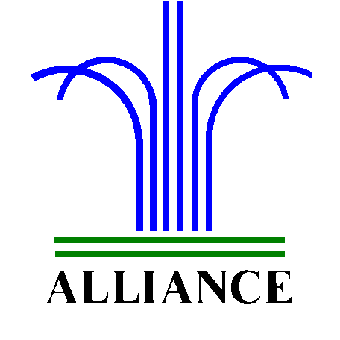City of Alliance ~ P. O. Box D ~ Alliance, NE 69301~ (308) 762-5400

August 20 2024

FOR IMMEDIATE RELEASE

Story Time Adventures and LEGO Club at Alliance Public Library

Alliance, NE – Upcoming themes for Story Time A to Z at Alliance Public Library includes A is for Autumn on September 3 and 5, Beautiful B on September 10 and 12, Creative C on September 17 and 19 and Dynamic D with Dance Party on September 24 and 26. Story Time for ages 3-6 is offered on Tuesdays at 10 am and Thursdays at 1 pm in the Children’s Room with several stories, birthdays, music, puppets and a craft project for a total of 45 minutes.
LEGO Club for grades K-3 meets on the first and third Tuesdays each month from 4-5 pm in the Community Room, including September 3 and 17.
Please register your child(ren) for these events at the circulation desk and for more information, contact Cynthia Horn, Children’s and Youth Services Librarian.

