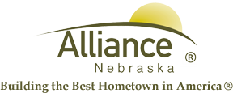

August 16, 2024

FOR IMMEDIATE RELEASE

Water Conservation for the Community

Alliance, NE – The City of Alliance Water Department would like to remind the community to practice water conservation during high temperature months. High water demand places a strain on the City’s water system.

Different ways residents can aid with water conservation is by watering lawns in the early morning and less frequent; use a broom to clear walkways/driveways; and refrain from running faucets and other household appliances such as; washing machines and dishwashers excessively.

Please contact the Public Works Facility at (308) 762-1907 for more information or with questions on how you can practice water conservation.

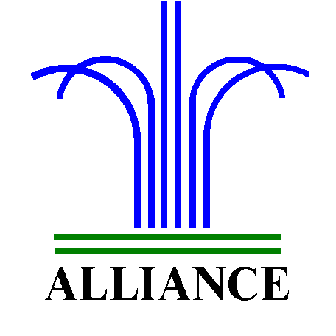 City of Alliance ~ P. O. Box D ~ Alliance, NE 69301~ (308) 762-5400

