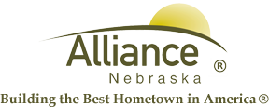

July 30, 2024

FOR IMMEDIATE RELEASE

Big Blue Bay Closure

Alliance, NE – Big Blue Bay will be closed the rest of the day, Tuesday, July 30th. There will be normal hours of operation tomorrow, Wednesday, July 31st.
For more information, please contact Shana Brown at (308) 762-2384.

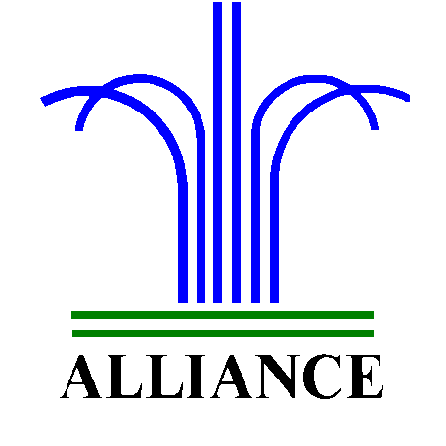 City of Alliance ~ P. O. Box D ~ Alliance, NE 69301~ (308) 762-5400

