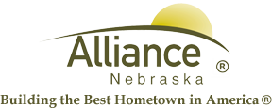

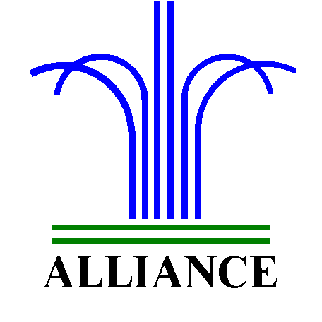 City of Alliance ~ P. O. Box D ~ Alliance, NE 69301~ (308) 762-5400

July 26, 2024

FOR IMMEDIATE RELEASE

Prairie Dog Educational Meeting at Knight Museum & Sandhills Center

Alliance, NE – Box Butte County and Sheridan County will be hosting a Prairie Dog Educational Meeting on Thursday, August 1, 2024 at 2:00 pm at The Knight Museum & Sandhills Center.

