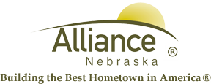

June 28, 2024

FOR IMMEDIATE RELEASE

Independence Day Closures

Alliance, NE – The City of Alliance Facilities will be closed Thursday, July 4, 2024 in observance of Independence Day. This closure includes the Utility Office, Public Works, Alliance Public Library, Sallows Military Museum, Public Transit, Alliance Municipal Landfill and the Municipal Building. All offices will resume their regular hours on Friday, July 5th.

The Knight Museum will be open on Thursday, July 4th from 1:00 pm to 4:00 pm.

Please contact the City Administration Offices at (308) 762-5400 for any questions or for more information.

