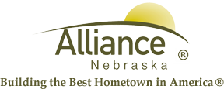

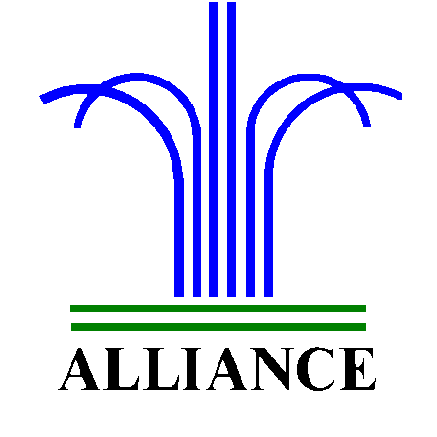 City of Alliance ~ P. O. Box D ~ Alliance, NE 69301~ (308) 762-5400

June 18, 2024

FOR IMMEDIATE RELEASE

Breakout Box Adventure and Book Clubs at Alliance Public Library

Alliance, NE – Breakout Box Adventure for grades K-5 will feature “Road Trip Rescue” on Wednesday, June 19 from 4-5 pm. Solve the puzzles and help locate the keys so we can take this trip on the road!
Adventure Book Club for grades 3-5 will share discussion of The Campground Kids series by C. R. Fulton on Monday, June 24 from 4-5 pm.
Youth Book Conversation for grades 6-8 will share discussion of the Wings of Fire series by Tui T. Sutherland, both books and graphic novels, on Thursday, June 27 from 3-4 pm.
All of these events are in the APL Community Room. Please sign up for the book clubs at the circulation desk and each book you read in the series counts for one of your reading goals.
For more information, please contact Cynthia Horn, Children and Youth Services Librarian at 762-1387.

