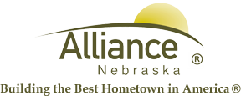

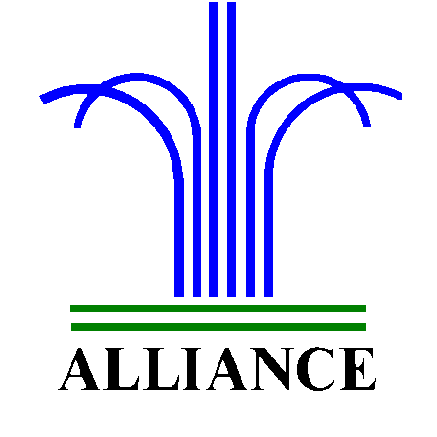 City of Alliance ~ P. O. Box D ~ Alliance, NE 69301~ (308) 762-5400

June 11, 2024

FOR IMMEDIATE RELEASE

Sam Stalos AI Presentation

Alliance, NE – Join the Alliance Public Library on Thursday, June 20th at 5 PM in the Community Room for an exciting presentation by Sam Stalos, a graduate of Alliance High School's Class of 1962. Stalos will be showcasing "Producing Audio and Visuals with AI," demonstrating how to create audiobooks, videos, graphic designs, and visual art using artificial intelligence.

For more information, please call 308.762.1387 or email nstewart@cityofalliance.net.

