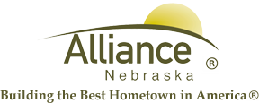

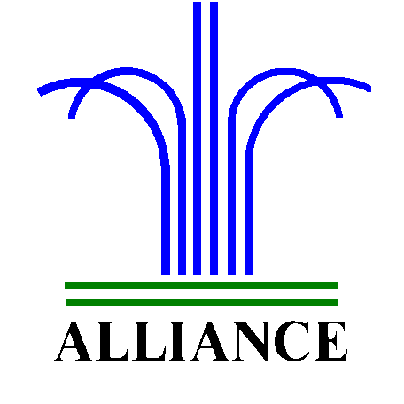 City of Alliance ~ P. O. Box D ~ Alliance, NE 69301~ (308) 762-5400

June 11, 2024

FOR IMMEDIATE RELEASE

Keno Community Day

Alliance, NE – Friday, June 14, 2024 has been proclaimed as Alliance Community Day by Lotto Nebraska and the Nebraska Cooperative Government.

On Friday, June 14, 2024 only, Keno players can win a $7,000 bonus jackpot in the event the player bets $1.00 or more on a “7 spot” at The Gathering Spot in Alliance. This offer is only good between the hours of 6am through 1am on June 14, 2024.

In the event that there is more than one winner, then all winning tickets will share equally in the $7,000. If you have a winning ticket, please call 800-852-6707.

For more information, please contact Lotto Nebraska (402) 471-6100.

