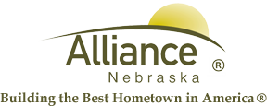

June 6, 2024

FOR IMMEDIATE RELEASE

Flag Retirement at Sallows Military Museum

Alliance, NE – The American Legion will be presenting a flag retirement ceremony at the Sallows Military Museum on Flag Day, Friday, June 14th beginning at 9:00am.

If you have old or tattered flags, please bring them to the Sallows Military Museum on or before June 13th.

For more information, please contact Becci Thomas at the Knight Museum by calling (308) 762-2384.

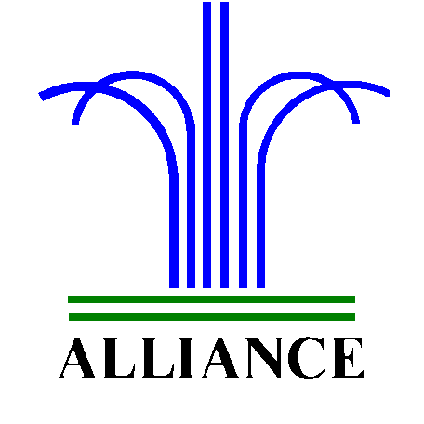 City of Alliance ~ P. O. Box D ~ Alliance, NE 69301~ (308) 762-5400

