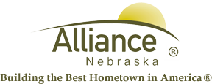

May 29, 2024

FOR IMMEDIATE RELEASE

Reading and Robots with 4-H at Alliance Public Library

Alliance, NE – “Adventure Begins At Your Library” Summer Reading 2024 is in full swing with plenty of exciting adventures for ages 3 through grade 12, so get registered at Alliance Public Library to join in!
Grades K-5 are invited to Robot Adventures with 4-H on Thursday, June 13 from 10-11:30 am with Melissa Mracek, Extension Educator. Please sign up at the circulation desk so we know you’re coming.
Adventure Book Club for grades 3-5 features The Campground Kids series by C. R. Fulton. Sign up at the circulation desk with day/time of discussion determined by the group.
Youth Book Conversation for grades 6-8 features the Wings of Fire series by Tui T. Sutherland, both books and graphic novels. Sign up at the circulation desk with day/time of discussion determined by the group.
For more information, please contact Cynthia Horn, Children’s and Youth Services Librarian at 762-1387.

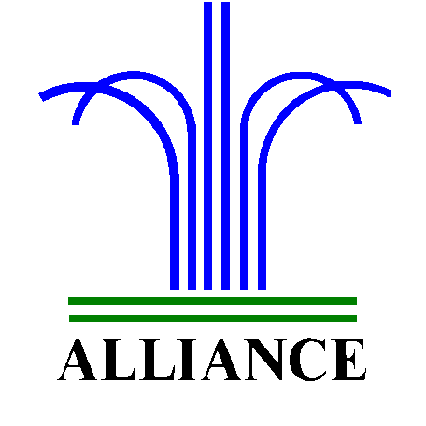 City of Alliance ~ P. O. Box D ~ Alliance, NE 69301~ (308) 762-5400

