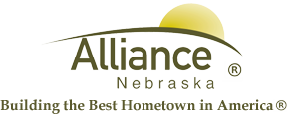

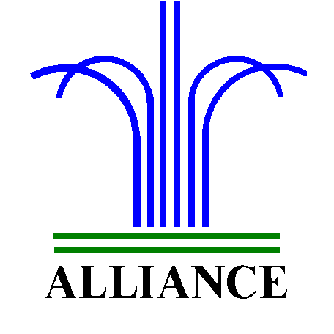 City of Alliance ~ P. O. Box D ~ Alliance, NE 69301~ (308) 762-5400

May 28, 2024

FOR IMMEDIATE RELEASE

Artistic Adventures at Alliance Public Library

Alliance, NE – Registration continues for “Adventure Begins At Your Library” with reading goals, special events and $3,500 in prize value sponsored by the Alliance Public Library Foundation! Grand prize drawings are for those who complete all five weeks of reading with the first week ending on Friday, May 31 before noon, so get registered and get started in your summer reading adventures.
Artistic Adventures include Watercolor Wednesday on June 5 from 10-11:30 am for those who have completed kindergarten and over with all supplies provided. Recycled Crafts with Keep Alliance Beautiful is Tuesday, June 11 from 2-4 pm for preschool and over with their families and all supplies are provided for your creative masterpieces.
Stuffy Adventure will be Wednesday, June 26 from 4-5 pm for those who have completed kindergarten and over. There is a cost of $25 per stuffy and families are welcome to attend together. Registration with stuffy choice and payment is due by Friday, June 7.
All of these events are in the APL Community Room and for more information, please contact Cynthia Horn, Children’s and Youth Services Librarian at 762-1387.

